Conflict Criminal Defenders

Claims Portal User Guide
  - CCD Claims Portal Version: 1.0
  - Document Version: 1.02
  - January 28, 2016

Contents
Introduction 3
Getting Started 3
Online Assigned Attorney Claim Form 4
Save Draft 5
Delete Draft 5
Submit to CCD 5
Return to Claim List 6
Claim Form Sections 7
Attorney Information 7
Client Information 7
Claim Information 7
Itemized Activity 8
Add Attachments 11
Review and Redaction Activity 12
Itemized Expenses 14
Statement of the Nature of the Case 16
Calculations and Costs 16
Files Attached to the Claim 16
Declaration Pursuant to Penal Code Section 987 16

Date | Document Revision | CCD Claims Portal Version | Comments
1/28/16 | 1.02 | 1.0 | Final updates
1/5/16 | 1.01 | 1.0 | Updates based on application enhancements
5/14/15 | 1.0 | 1.0 | Initial release of user guide

Introduction
The Conflict Criminal Defenders (CCD) Claims Portal allows attorneys to submit claims to CCD for compensation according to CCD Policies and Procedures for assigned counsel. The Portal accepts attorney claims for criminal cases. All claims are subject to review and approval by CCD staff. The Portal is a replacement for the previous WebBill system. It contains all prior functionality and more with an updated user interface and technology platform.
All claims are reviewed by CCD staff prior to processing. If there are any discrepancies or details which need clarification, CCD will reach out to you and work with you to finalize the claim.

Getting Started
Log in to the CCD Claims Portal with your California Bar Association ID and your PIN number. Your PIN number has been migrated from the previous WebBill system. If needed, contact CCD to be assigned a PIN or retrieve a forgotten PIN.
The Attorney Claims home screen lists all draft claims in order by the last date the claim was saved. From this screen, you can start a new claim. You may also edit, delete, or submit an existing claim.
Click Logout in the upper right hand corner of the screen to end your session. You can logout from the home screen or the claim form screen.

WARNING: For security reasons the system times out after twenty minutes of inactivity. Any claim information entered after the timeout period cannot be saved. As you complete the claim form, click the Save Draft button periodically to keep your session active. After a period of inactivity, please click logout and log in to the system again before entering claim information. The form does allow data entry even after a system timeout but the data will not be saved if the session has timed out.

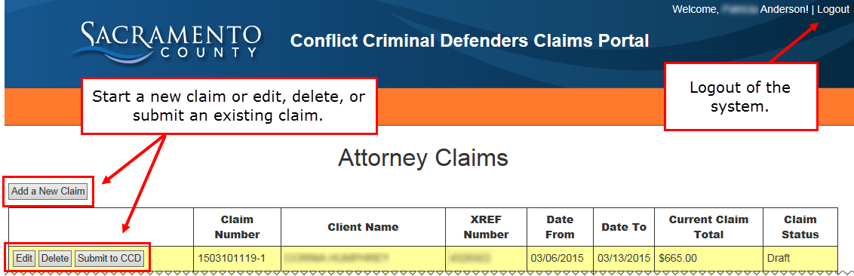

Online Assigned Attorney Claim Form
The online Assigned Attorney Claim Form is based on the legacy paper form. Click to expand or collapse each section. Sections that are shaded red and include the word “Error” require information before you can either save a draft or submit your claim (depending on the specific error). See Save Draft and Submit to CCD for more information.

Once information is entered into a section, a summary of the information will display in the section header. For example, the case number and client name will display next to Client Information once a client is selected.
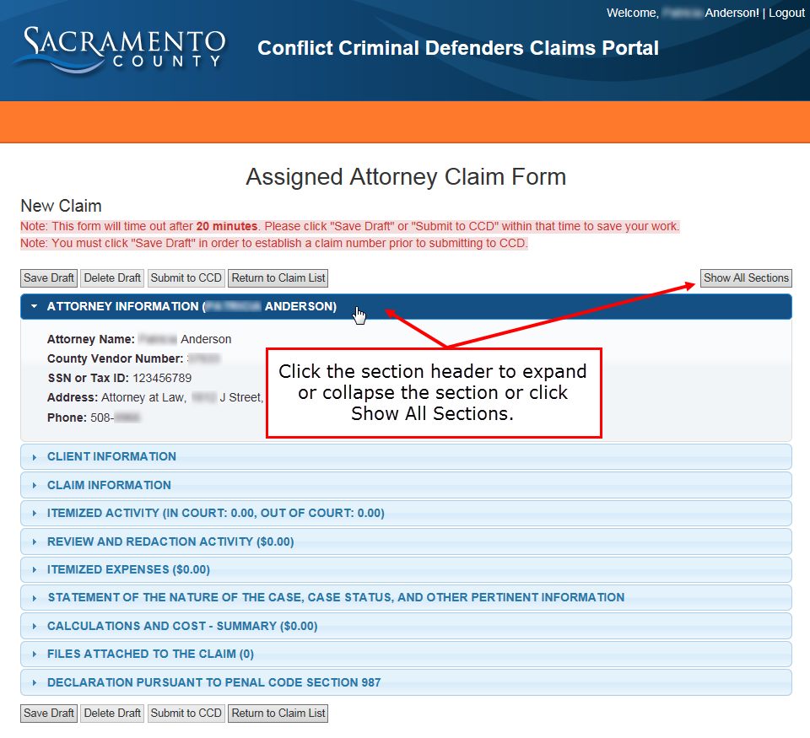

Save Draft
To save a claim as a draft, a client must be selected under Client Information. Other errors do not need to be resolved to save the claim as a draft.
A Claim Number will generate once you select a case under Client Information and click Save Draft.
Clicking Save Draft also resets the system time out. When completing the claim form, remember to save it periodically as a draft to prevent lost work due to a system time out.
Important: Itemized activities, review and redaction activities, expenses, and attachments can be added on the screen, but they are not saved to the claim until the Save Draft or Submit to CCD button is clicked.
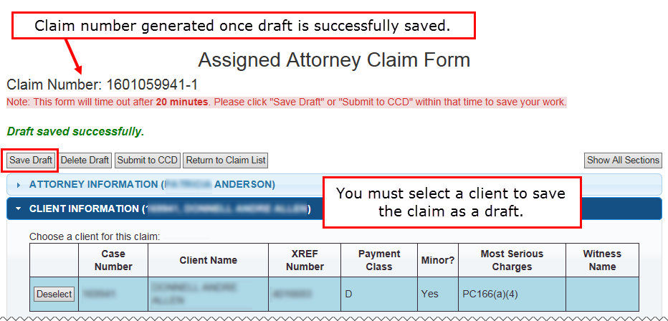

Delete Draft
Click the Delete Draft button to discard the current claim form draft. You may also do this from the home screen. Deleted drafts cannot be retrieved.

Submit to CCD
Before the system will allow you to submit a claim to CCD:
- A client must be selected.
- At least one line item of any kind must be entered under Itemized Activity, Review and Redaction Activity, and/or Itemized Expenses.
- A Statement of the Nature of the Case must be entered.
- The Declaration must be completed including the Declarant’s full name and City, State.
- All other errors must be resolved.
Review the claim, print it using your browser’s print functionality, and retain the claim number for your records before clicking Submit to CCD. Once the claim is submitted, it will not appear in the claims list on the home screen.
If you click Submit to CCD from the home screen, and there are errors on the claim, then the claim will open for you to correct the errors before submitting.
If you click Submit to CCD from the home screen, and there are no errors, the claim will be submitted.

Return to Claim List
To return to the Attorney Claims list home page, click Return to Claim List.

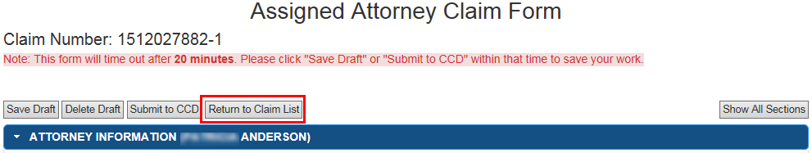
When you click Return to Claim List the following warning will appear.
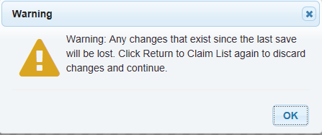
To discard any changes made since your last save, click OK and then click Return to Claims List again. The warning message will not appear this time, and you will return to the Attorney Claims List home page.
To save any changes made since your last save, click OK and then click Save Draft. Once the “Draft saved successfully” text appears below the claim number click Return to Claims List. You will get the warning message again. To proceed to the Attorney Claims List home page, click OK and then click Return to Claims list again.
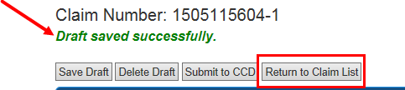

Claim Form Sections

Attorney Information
Attorney information is populated by CCD based on the login account. Contact CCD to make any changes.

Client Information
The Clients assigned by CCD to the logged-in attorney are listed in the Client List. Click Select to associate a case with the claim form. If the wrong case is selected, click Deselect and the Client List will reappear. Contact CCD if the case or client does not appear in the Client List.
Note: If an attorney is representing the same client on multiple cases, each case will be listed separately. Be sure to select the appropriate case number for the claim submitted.
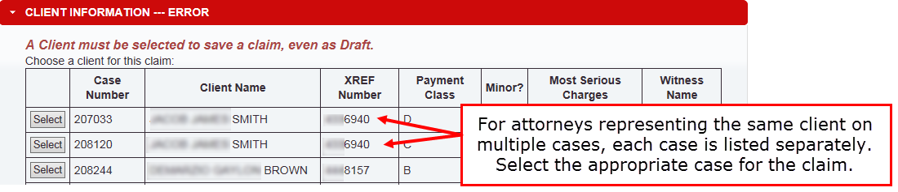

Claim Information
Date Accepted Case, Date From, Date To, and Date of Last Claim Submitted are populated automatically from CCD’s database. If there are errors, please contact CCD.

Review the four questions under the Claim Information section. The system default answer is ‘No’. If ‘Yes’ is selected for any of the first three questions, an error will appear. The associated text box must be completed before submitting the form.
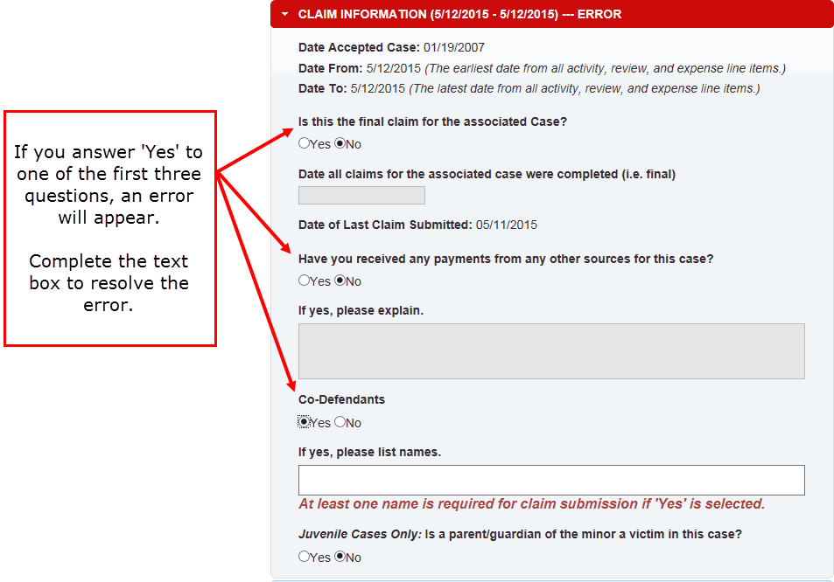

Itemized Activity
Activities are to be listed separately. Add corresponding attachments after an activity is added.
- Click Add New Activity Item. A window will open to for you to record your activity.
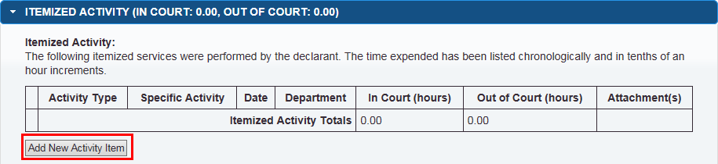

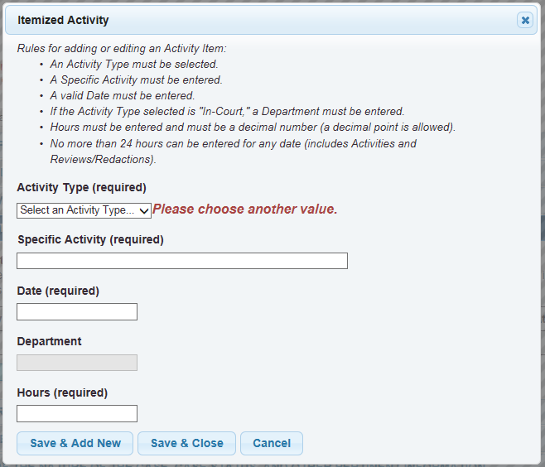

- Select an Activity Type from the list. This field is required.
- Describe the specific activity in detail. This field is required.
Examples include: conference with client at jail, preparation of 995 motion, etc.
For client conferences please state where the conference took place.

- Enter the date that the activity was performed. This is required.
- Enter Hours spent on activity. This field is required. The hours will be calculated as In Court or Out of Court hours based on the Activity Type selected. Hours must be entered as numerical digits and decimal points are allowed, for example .2 or 1.3.
Note: No more than 24 hours of activity, including review and redaction, may be entered for any date.
- In Court hours – services performed while Court is in session either in court or in chambers.
  - If “In Court Hours” are added, you must also list a Department.

  - Out of Court hours – all other time except that identified by CCD as non-billable.
  - Non-Billable services are defined in the CCD Policies and Procedures found here: http://www.ccd.saccounty.net/Pages/PoliciesProcedures.aspx

- Click Save & Add New or Save & Close to add this item to the claim form. Save & Add New allows you to save this activity and add another without closing and reopening the dialog.
The system arranges the activities in chronological order based on the date selected.
Important: Itemized Activities are not saved to the claim until the Save Draft or Submit to CCD button is clicked.

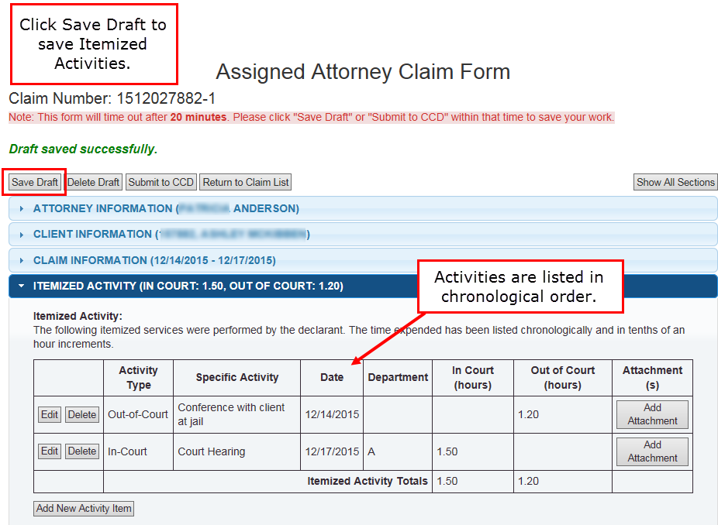

Add Attachments
Add attachments after the activity (or expense) is added to the list. Follow these instructions to add an attachment in Itemized Activity, Review and Redaction Activity, and/or Itemized Expenses.
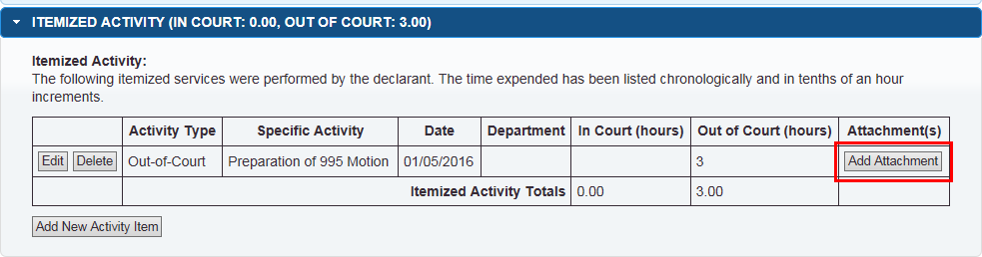
- Click Add Attachment in the far right column of the Itemized Activity or Expense list. The Attachment dialog window will appear.
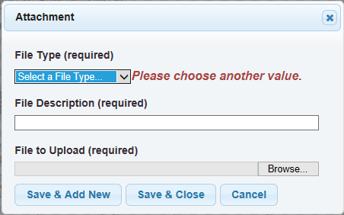
- Select the file type from the dropdown menu. This is required.
- Maximum Compensation Declaration
- Motion or Pleading
- Memo
- Receipt
- Miscellaneous documents
- Add a file description. This is required.
- Click Browse to select the document to upload. The system will accept any file type. This is required.
- Click Save & Add New or Save & Close to add this file to the claim form. Save & Add New allows you to save this attachment and add another without closing and reopening the dialog.
Important: Attachments are not saved to the claim until the Save Draft or Submit to CCD button is clicked.
Once the file is uploaded:
- Click Edit to change the type or description of the attached file.
- Click View to download the attached file.
- Click Delete to remove the file from the claim form.
- Click Add Attachment to include additional files.
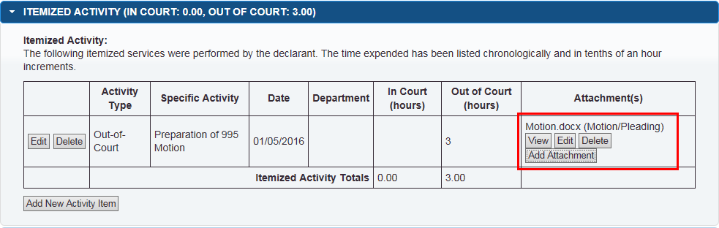

Review and Redaction Activity
Itemize record review, redaction, or jail tape review activities in this portion of the claim form. The system will automatically calculate a subtotal amount based on input in this form. Once activities are added to the list, attachments can be added.
- Click Add New Review Item. The Review or Redaction Activity window will appear to log your activity.
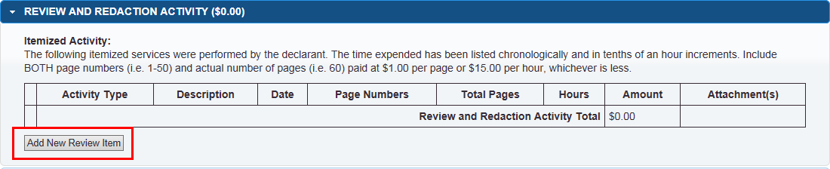
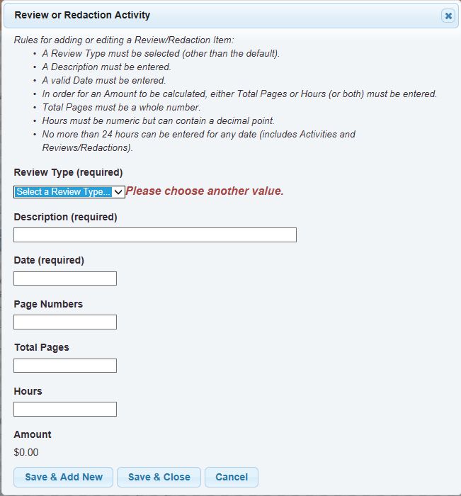
- Select review type from the dropdown list. This is required.
  - Record Review
  - Redaction
  - Jail Tape Review

- Type a description of the activity. This is required. For example, reviewing pages 1–25 of 200 pages of discovery.
- Enter the date that the review activity was performed. This is required.
- For document review or redaction, enter page numbers reviewed. Page numbers can be a range, e.g. 1-120.
- Enter total pages and/or hours for the amount to be calculated.
- Total pages must be a whole number and a numerical digit, e.g. 25.
- Hours must be entered as numerical digits and decimal points are allowed, e.g., 0.2 or 1.3 hours.
- No more than 24 hours of activity, including review and redaction, may be entered for any date.
For Record Review: Enter either the total pages or hours or both. At least one field is required, both are recommended.
- Amount is based on either the current page rate or the hourly review rate.
- If both total pages and hours are entered, the system displays the lesser amount.
For Redaction: Enter both the total pages and the hours. Both are required for the system to calculate the amount.
- Amount is based on the current hourly redaction rate and page per hour benchmark.
For Jail Tape Review: Enter the number of hours spent reviewing tapes.
- The system will generate an amount based on the current hourly review rate.
Current rates can be found in the CCD Policy and Procedures.
- Click Save & Add New or Save & Close to add this item to the claim form. Save & Add New allows you to save this attachment and add another without closing and reopening the dialog.
The system lists review and redaction activities in chronological order.
Important: Review and Redaction Activities are not saved to the claim until the Save Draft or Submit to CCD button is clicked.
See Add Attachments for instructions on adding files.
Note: If a paralegal performs review or redaction activities, review CCD Policy and Procedures for attorney claim guidance. Log any attorney time spent briefing or de-briefing the paralegal in conjunction with these activities in the Itemized Activity Section not in the Review and Redaction Activity section to calculate the correct amount.
Find the CCD Policy and Procedures here: http://www.ccd.saccounty.net/Pages/PoliciesProcedures.aspx

Itemized Expenses
Add expense items and corresponding invoices or receipts to this section. To process the claim, CCD must receive either the original or a scanned copy of any invoice(s) or receipt(s).
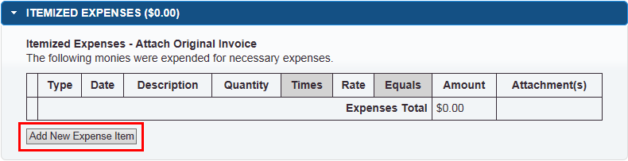
- Click Add New Expense Item. The Expense Activity window will appear to log your activity.
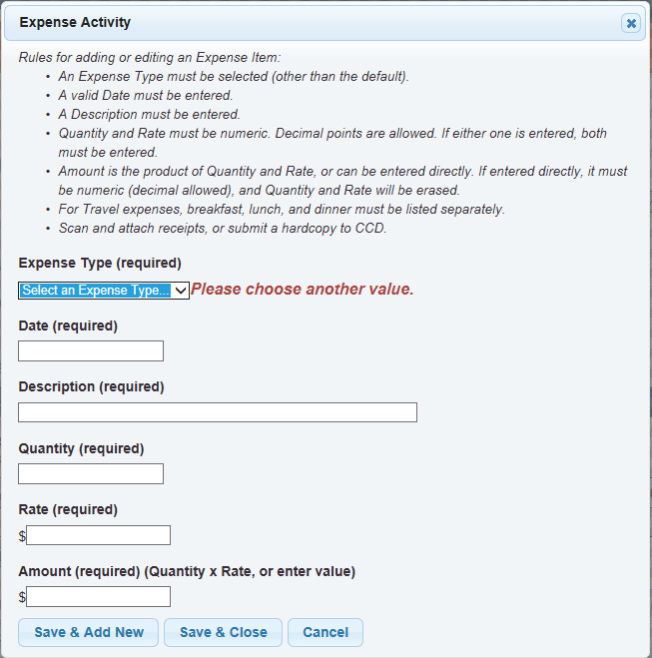
- Select the expense type. This is required. The fields will change based on your selection.
- Enter the date that the expense was incurred. This is required.
- Type a detailed description of the expense, for some expense types this field is required.
- Enter the expense amount.
For copies enter the quantity and authorized rate to calculate the amount. If amount is entered directly then quantity and rate will reset. All three fields must have a numeric value.
For mileage enter the miles traveled and the County mileage rate in effect on the day mileage was claimed. If amount is entered directly then miles and rate will reset. All three fields must have a numeric value.
Enter meals as travel expenses. Meals must be entered as line items: breakfast, lunch, dinner.
For all other expense types, enter the claim amount. This field is required and must be numeric digit(s).

- Click Save & Add New or Save & Close to add review or redaction activity to claim form. Save & Add New allows you to save this attachment and add another without closing and reopening the dialog.
Expense items are listed in chronological order.
Important: Expenses are not saved to the claim until the Save Draft or Submit to CCD button is clicked.
See Add Attachments for instructions on how to add scanned copies of invoices or receipts.

Statement of the Nature of the Case
A statement of the nature of the case is required in order to submit the online claim form. Reference the CCD Policy and Procedures for more information on what to include in your statement: http://www.ccd.saccounty.net/Pages/PoliciesProcedures.aspx

Calculations and Costs
This section provides a summary of billable hours, total expenses, and review and redaction fees. The rate for billable hours is automatically populated based on the case selection made in Client Information and CCD Policies and Procedures. Ensure that the total hours, rates, fees, etc., are correct before submitting the claim. If the Portal does not allow for correction of a particular field, contact the CCD office for guidance.

Files Attached to the Claim
Attach only general case files in this section of the claim. Attach files, invoices, or receipts associated with a specific expense or activity to the appropriate previous section. See Add Attachments.

Declaration Pursuant to Penal Code Section 987
This section is required to submit the claim form to CCD.
- Enter City and State. This is required.
- Enter the full name of the Declarant. This is required.
- The date will automatically populate when the claim is saved and update when the claim is submitted.

